How to do Practical Deep learning
1)
Implementing Feed-forward neural networks with Keras and TensorFlow
a. Import the necessary packages
b. Load the training and testing data (MNIST/CIFAR10)
c. Define the network architecture using Keras
d. Train the model using SGD
e. Evaluate the network
f. Plot the training loss and accuracy
---->
Step 1: open window
Step 2: go to colab in chrom or firbox browser.
Step3 : create new file
Step 4: firstly write your question in first line like below:
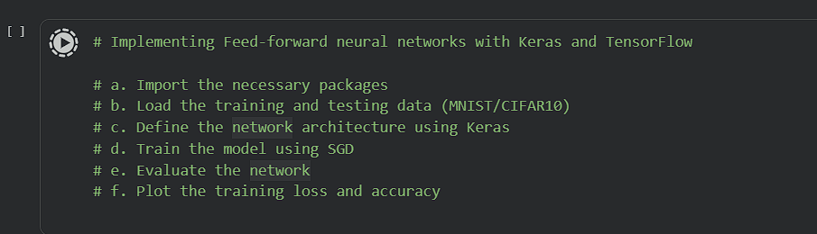
Step 5: Implements your code as per given below link:
https://colab.research.google.com/drive/1oLlJmR1mtrdw3s8UxcpVpR2rxwjczzyI?usp=sharing

2) Build the Image classification model by dividing the model into the following fourstages:

a. Loading and preprocessing the image data
b. Defining the model’s architecture
c. Training the model
d. Estimating the model’s performance
steps : follow all above steps except link
link for assignment 3:
https://colab.research.google.com/drive/1cflD6TmnysVFO7v9QETLrxL3PYXcZuiP?usp=sharing

3) Use Autoencoder to implement anomaly detection. Build the model by using the following:

a. Import required libraries
b. Upload/access the dataset
c. The encoder converts it into a latent representation
d. Decoder networks convert it back to the original input
e. Compile the models with Optimizer, Loss, and Evaluation Metrics
- follow all above steps and then link :
https://colab.research.google.com/drive/1fM9iZkr0aYRKqNjPLbAO-H99_fcz9xaq?usp=sharing

4) Implement the Continuous Bag of Words (CBOW) Model. Stages can be:

a. Data preparation
b. Generate training data
c. Train model
d. Output
link: https://colab.research.google.com/drive/1KaWtsvMT_gCL9Pu7fq6Ptz5cXCtkWhcQ?usp=sharing

5) Object detection using Transfer Learning of CNN architectures
Load in a pre-trained CNN model trained on a large dataset
b. Freeze parameters(weights) in the model’s lower convolutional layers
c. Add a custom classifier with several layers of trainable parameters to model
d. Train classifier layers on training data available for the task
e. Fine-tune hyperparameters and unfreeze more layers as needed

- Link: https://colab.research.google.com/drive/1k254ulIPR3y_jMMqZafpvJfNXnu9BM8J?usp=sharing

